EXPERIMENT 3
DATE:
Determination and plotting of Force of attraction between two electric Charges and two parallel conductors separated by varying distance.
Aim:
To determine and plot the Force of attraction between two electric Charges and two parallel =conductors separated by varying distance between them using MATLAB.
Software required:
•MATLAB (R2018 or later)
Theory:
Program:
Test case (i) Determination and plotting of force between two electric charges with varying distance
clc;
clear;
q1 = input('Enter the charge q1=');
q2 = input('Enter the charge q2=');
epsilon = 8.854e-12;
k = 1/(4*pi*epsilon);
r = linspace(0.1,10,100);
F = k*q1*q2./(r.^2);
disp('Force at r = 1 m is:');
disp(k*q1*q2/(1^2));
plot(r,F,'LineWidth',2);
xlabel('Distance (m)');
ylabel('Force (N)');
title('Force between two electric charges');

Output:-
Enter the charge q1=2e-6
Enter the charge q2=3e-6
Force at r = 1 m is:
0.0539 N
Graph: Force decreases with distance (1/r² behavior)
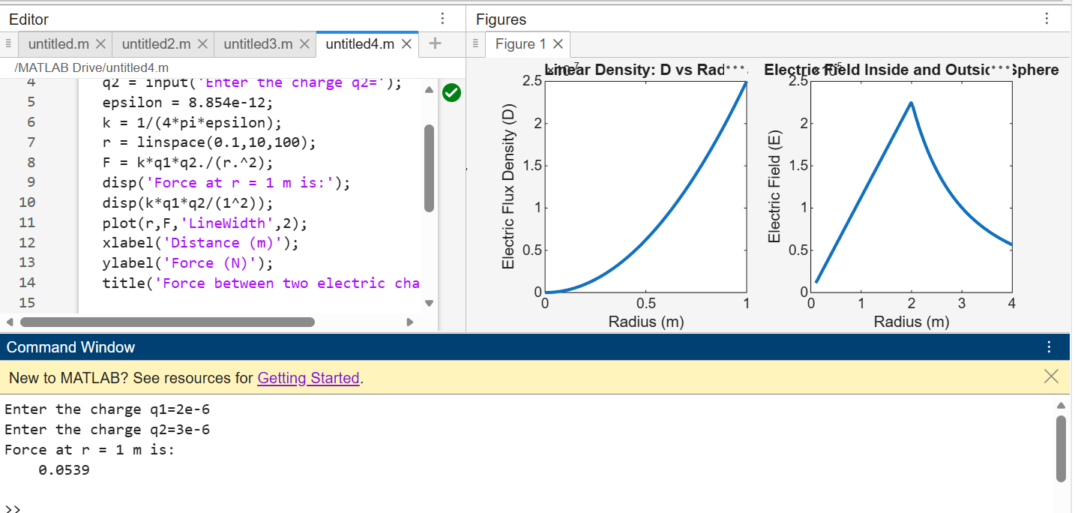

Test case (ii) Determination and plotting of force between two electric charges with different magnitudes
Code:
clc;
q1 = 5e-6;
q2 = 2e-6;
epsilon = 8.854e-12;
k = 1/(4*pi*epsilon);
r = linspace(0.5,5,100);
F = k*q1*q2./(r.^2);
plot(r,F,'LineWidth',2);
xlabel('Distance (m)');
ylabel('Force (N)');
title('Force between two charges (different magnitudes)');
Output:-
• Force magnitude increases with increase in charge
• Inverse square decay maintained
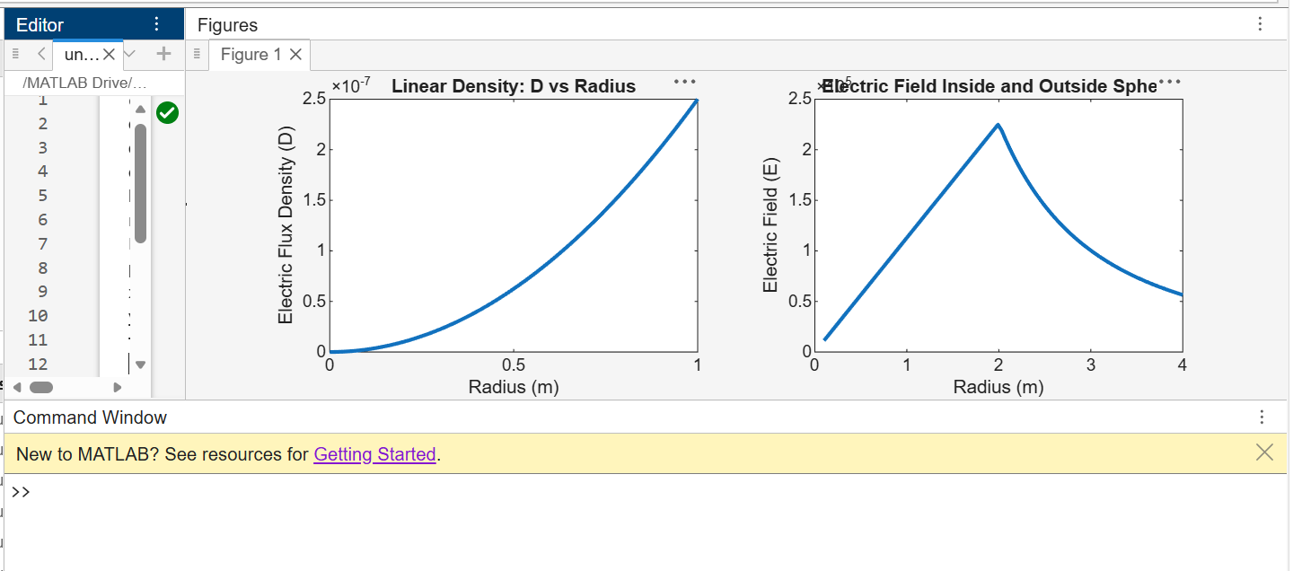
Test case (iii) Determination and plotting of force per unit length between two parallel conductors with varying distance
Code:
clc;
mu0 = 4*pi*1e-7;
I1 = 5;
I2 = 10;
d = linspace(0.1,10,100);
F = (mu0*I1*I2)./(2*pi*d);
plot(d,F,'LineWidth',2);
xlabel('Distance (m)');
ylabel('Force per unit length (N/m)');
title('Force between two parallel conductors');
Output:
• Force decreases with increase in distance
• Linear inverse relation (1/d)
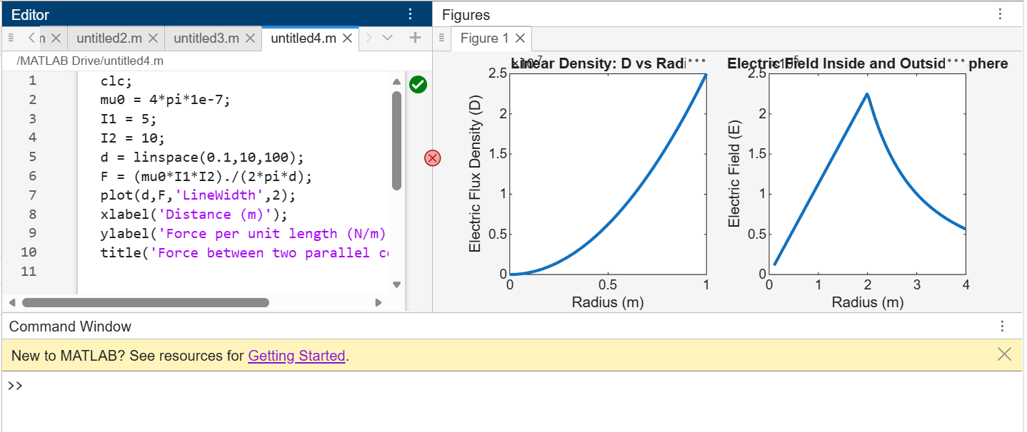

Test case (iv) Determination and plotting of force between two parallel conductors carrying equal currents
Code:
clc;
mu0 = 4*pi*1e-7;
I1 = 3;
I2 = 3;
d = linspace(0.1,2,100);
F = (mu0*I1*I2)./(2*pi*d);
plot(d,F,'LineWidth',2);
xlabel('Distance (m)');
ylabel('Force per unit length (N/m)');
title('Force between conductors
(equal currents)');
Output:-
Force magnitude reduced compared to
Test case (iii)
Same inverse relationship
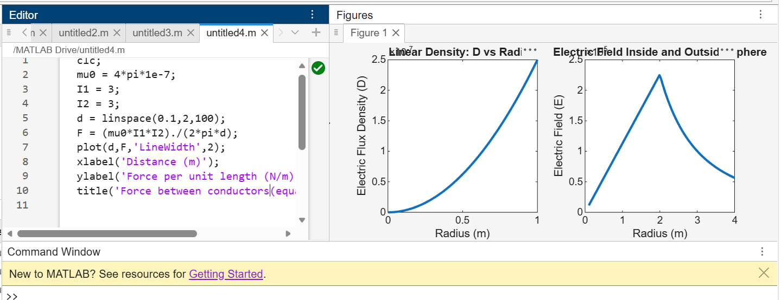

Results and Observations:
Parameters  q1=2e-6, q2=3e-6, r=1 m F = 0.0539 N q1=5e-6, q2=2e-6, r=1 m F = 0.0899 N I1=5 A, I2=10 A, d=1 m I1=3 A, I2=3 A, d=1 m | Observed/Simulated Result Theoretical Result Error Difference |  | ΔF ≈ 0  ΔF ≈ 0  ΔF ≈ 0  ΔF ≈ 0
 |  | F = 0.0539 N | ΔF ≈ 0  ΔF ≈ 0  ΔF ≈ 0  ΔF ≈ 0
 |  | F = 0.0899 N | ΔF ≈ 0  ΔF ≈ 0  ΔF ≈ 0  ΔF ≈ 0
 | F = 1×10⁻⁵ N/m | F = 1×10⁻⁵ N/m | ΔF ≈ 0  ΔF ≈ 0  ΔF ≈ 0  ΔF ≈ 0
 | F = 1.8×10⁻⁶ N/m | F = 1.8×10⁻⁶ N/m | ΔF ≈ 0  ΔF ≈ 0  ΔF ≈ 0  ΔF ≈ 0

Result :
Thus the program was verified for the force of attraction or repulsion acting along a straight line between two electric charges is directly proportional to the product of the charges and inversely to the square of the distance between them using SCILAB was successfully.
